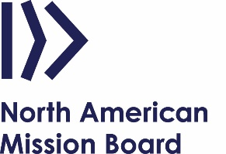

KNOW BEFORE YOU GO TO SPEAK
Churches request speakers by contacting NAMB through the Connection Center or online at NAMB.net. Most requests are during the Annie Armstrong Easter Offering season.
Here’s important information to help you prepare:

- Speaking opportunities are foremost to connect the church to NAMB and its initiatives and to thank churches for their gifts to the Cooperative Program and Annie Armstrong Easter Offering.
- NAMB asks that churches cover a speaker’s travel expenses and provide an honorarium unless the speaker is a NAMB staff member.
- Depending on what the host church provides financially, NAMB may also provide a stipend to help cover your expenses. Contact Mike Riggins for information: mriggins@namb.net
- For self-funded missionaries, please do not use this as an opportunity for personal fund-raising. The first speaking opportunity should be a means to building a relationship with the church for future fund-raising for your ministry.
- Speaker resources with talking points and graphics are available at www.namb.net/speakerresources
- Additional resources are available at:
  - www.AnnieArmstrong.com
  - www.namb.net

Prior to the Event:
Contact the host church to confirm the event details, expectations, audience and key information they would like for you to share. Research the following to aid in developing your messaging points:
- What is the pastor’s heart for missions in North America? How can you help further his vision?
- Does the church have a current or retired NAMB missionary? If so, find out his/her story and recognize him/her accordingly.
- Is the church a regular giver to CP? to AAEO? (Available in CRM database)
- Is the church a supporting or sending church with NAMB? (Mobilization team can provide this info.)

